Please use this format. You may have to move the boxes/ titles around with your curser. See sample. delete this

THAD Therapeutic Horticulture Activity Database

Activity: Goal: Populations:

TH Activity Plan –
Text by [Text Here]
Photo by [Text Here]
Optional—if relevant: Original publication: Author (last name, first initial.), (date). Publication. Volume #(Issue #). web link.

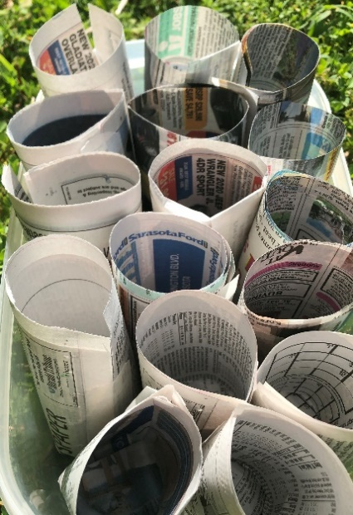
ACTIVITY DESCRIPTION:
[indent second line]

THERAPEUTIC GOALS:
Cognitive/Intellectual:
Physical:
Psychological/Emotional:
Sensory:
Social:

STEP-BY-STEP PROCESS:
- Pre-Session Preparation:
- Facilitator begins session by

Materials

Wipes

APPLICATIONS FOR POPULATIONS:

SAFETY CONSIDERATIONS: Facilitators are responsible for knowing poisonous and toxic plants and plant parts.

NOTES OR OTHER CONSIDERATIONS:

REFERENCES/ RESOURCES:

Edits were made for THAD purposes in 2024.
TH Activity Plan form developed by Lesley Fleming, Susan Morgan and Kathy Brechner (2012), revised in 2024.

